**StepWise Quoting Change Migration Steps**

Change 0062942 can be used as a reference for a Stepwise Change that involves migrating objects between environments.

**Intent:** To migrate packages between environments in the Stepwise Quoting tool. Packages are created in order to move objects between environments, allowing the business to create new formulas and objects to be available.

**Steps To Create A Package:**

1. Log into the Management Studio.

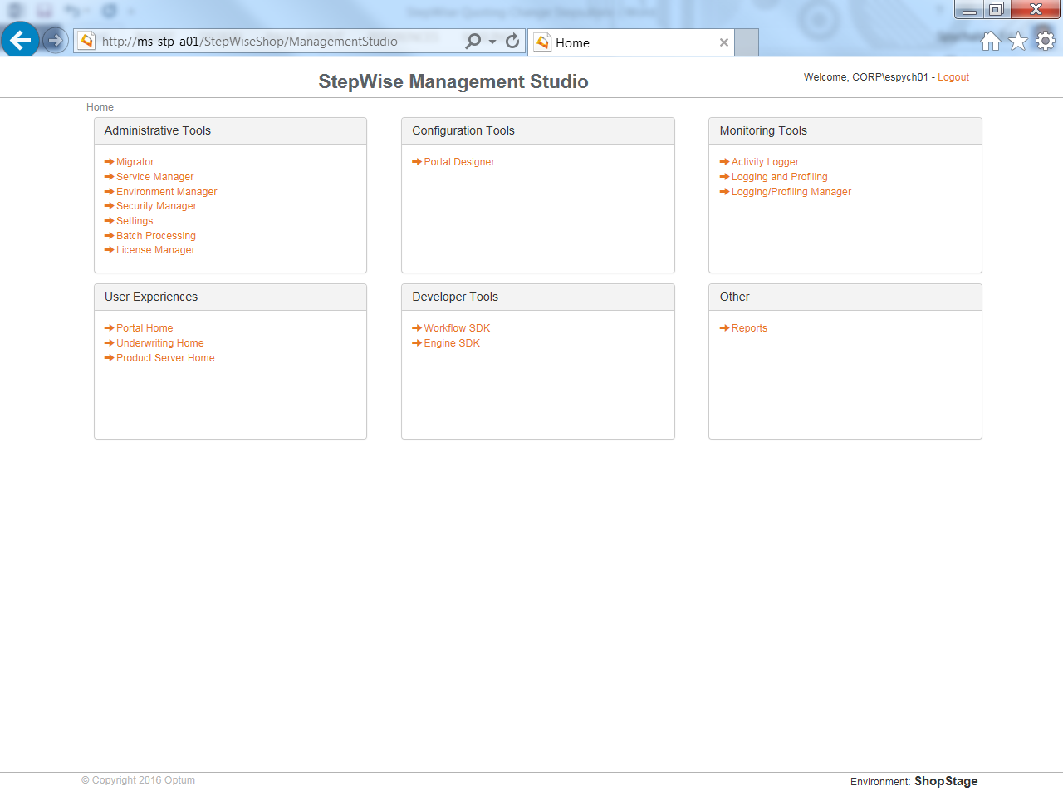

1. Enter Migrator.

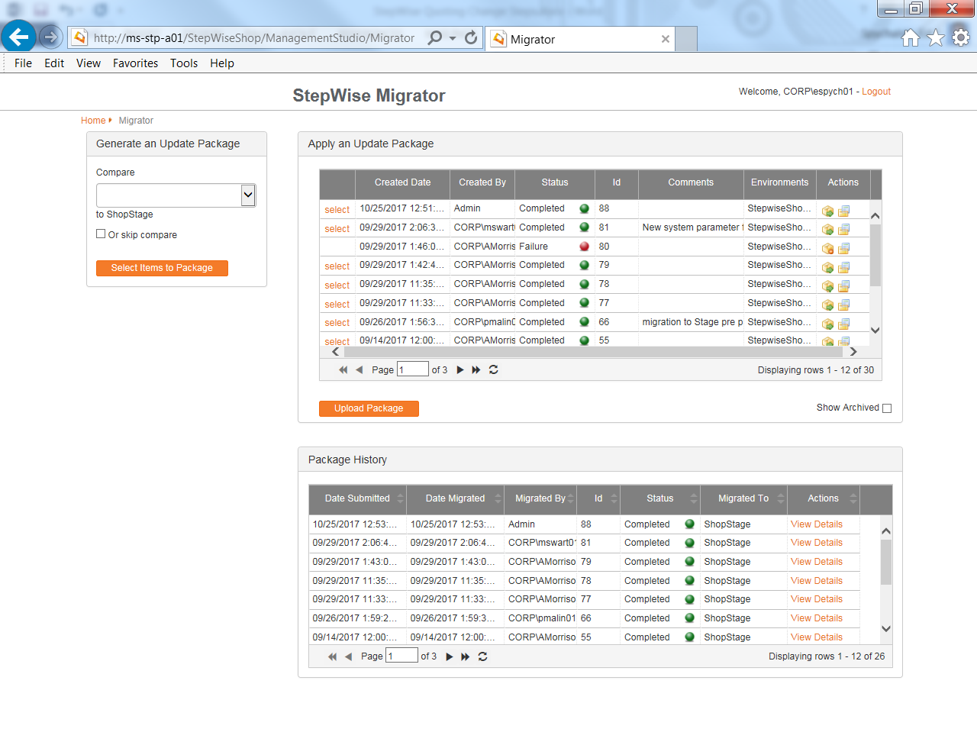

1. Select the next environment lower in the Compare dropdown. Click on the Select Items To Package button.

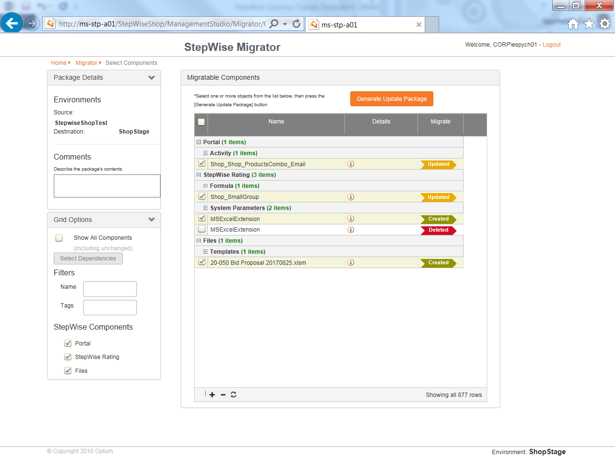

1. The screen will now show all items that are different between the source environment (next environment lower) and the current environment. Enter comments for the package. This will help others understand what the point of the change was. On the right, select any items that are part of the package. Not all items need to be promoted at once. This allows for us to only migrate objects related to our change without promoting other items that may still be in a testing phase. With all of the correct items selected, click on the Generate Update Package button.

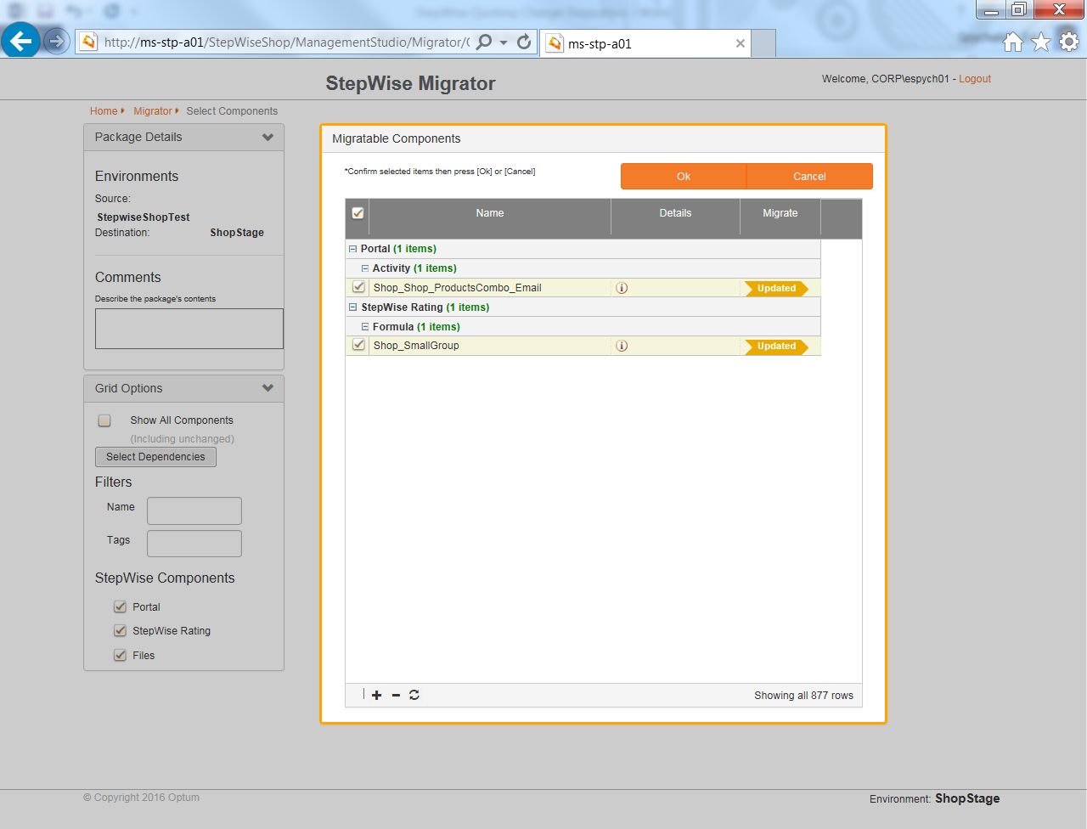

1. Click the OK button.

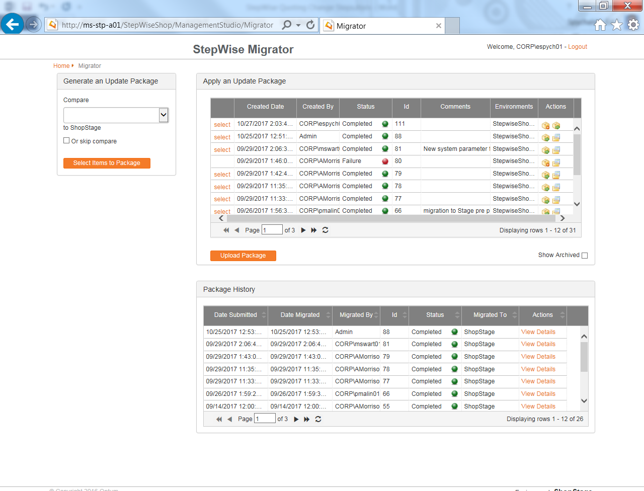

1. Your change will now be shown at the top of the screen. With the items that you selected within it. It is now ready to be migrated.

**Migration Steps:**

1. Notify the user community of the change time and alert them that they all need to be out of the system at that time. This has been done by working with Elaine Leonetti-Guy to communicate out to the group. She will make sure that the users know that the system is down.
2. Create your change document. I recommend looking at a previous change so that you have all of the correct information.
3. Open a conference bridge.
4. Have the DBA take a database backup of the StepWiseShop, StepWiseShop_Admin, and StepWiseShop_Logging databases on MP-STP-D01. They must then confirm to you that the backups are complete before proceeding. In the event that the change is not successful, we will need to restore to these backups. As of this writing (10/27/2017), all three databases in total are just a few hundred megabytes and take just over a minute to backup.
5. Stop all of the services. This can be done via the Service Manager in the Management Studio (<http://mp-stp-a03/StepWiseShop/ManagementStudio>) and must be stopped on all application servers. *(Note: If you see that there are any quotes in any of the engines, follow the steps in the appendix before continuing.)*

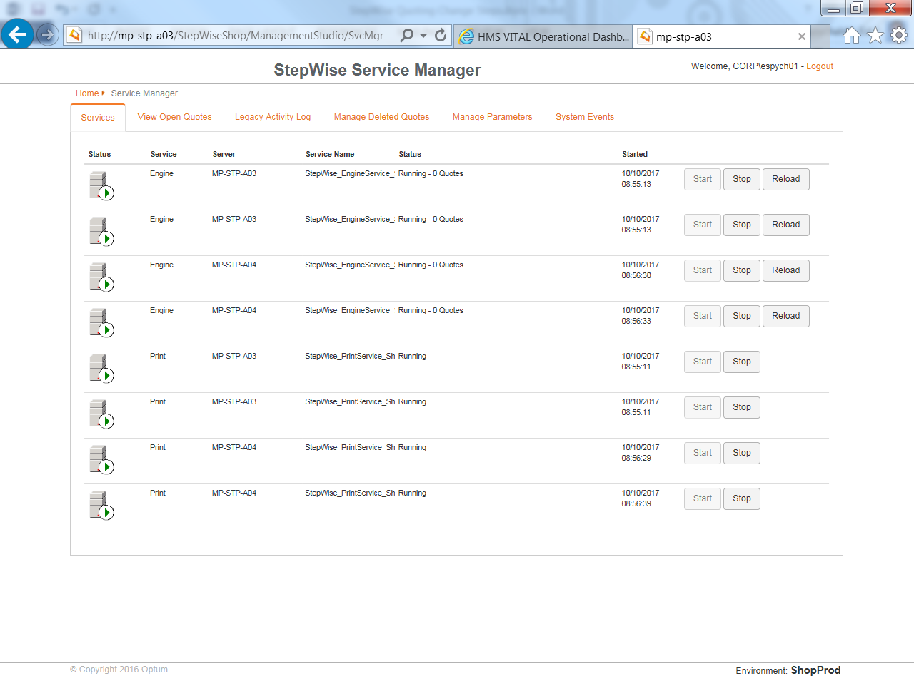

1. Navigate back to the Management Studio and enter the Migrator utility.

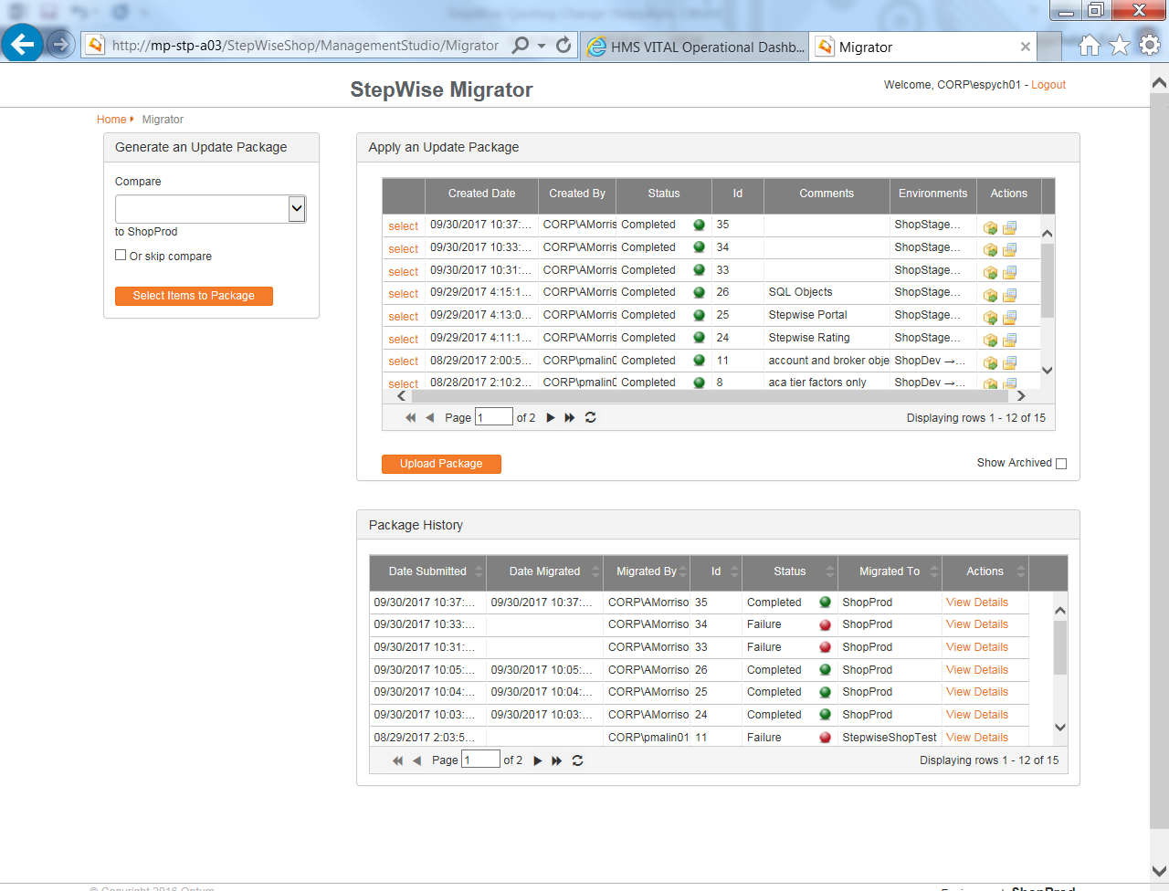

1. Click on the Select link next to the package to deploy.

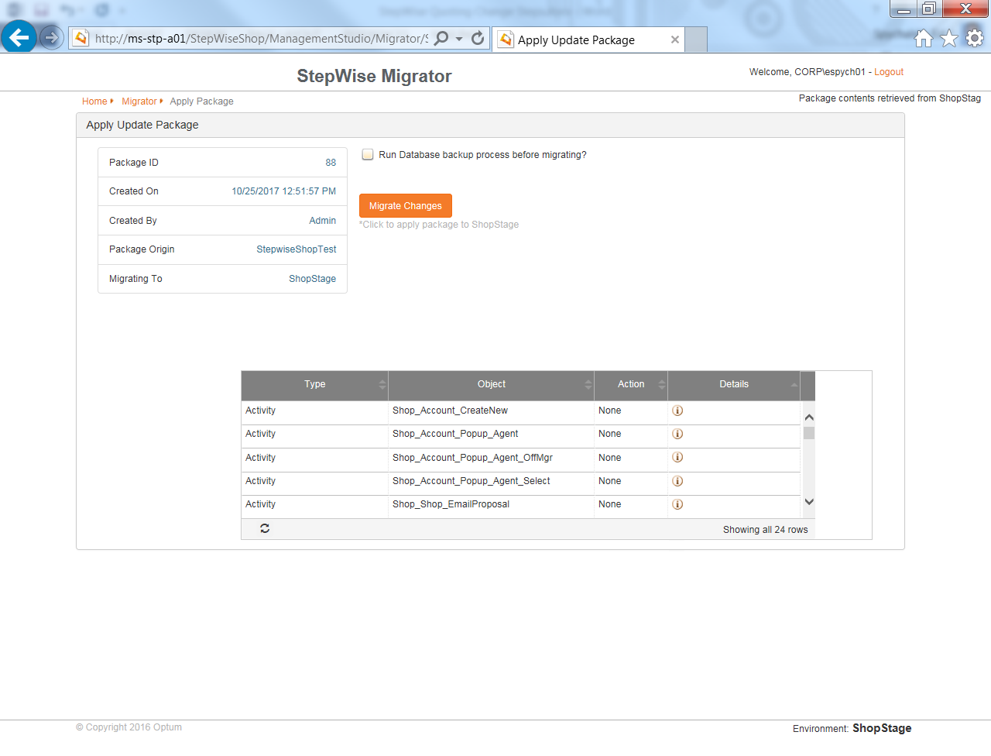

1. On this page, do not check the “Run Database backup process before migrating?” checkbox. Per Optum, this does not always work as intended and can create issues. The DBA has already taken the necessary backups. Confirm that the objects below are what are to be migrated. Click on the Migrate Changes button.
2. The package will deploy to the environment.
3. Verify that the package deployment occurred successfully in the package history portion of the Migrator utility.

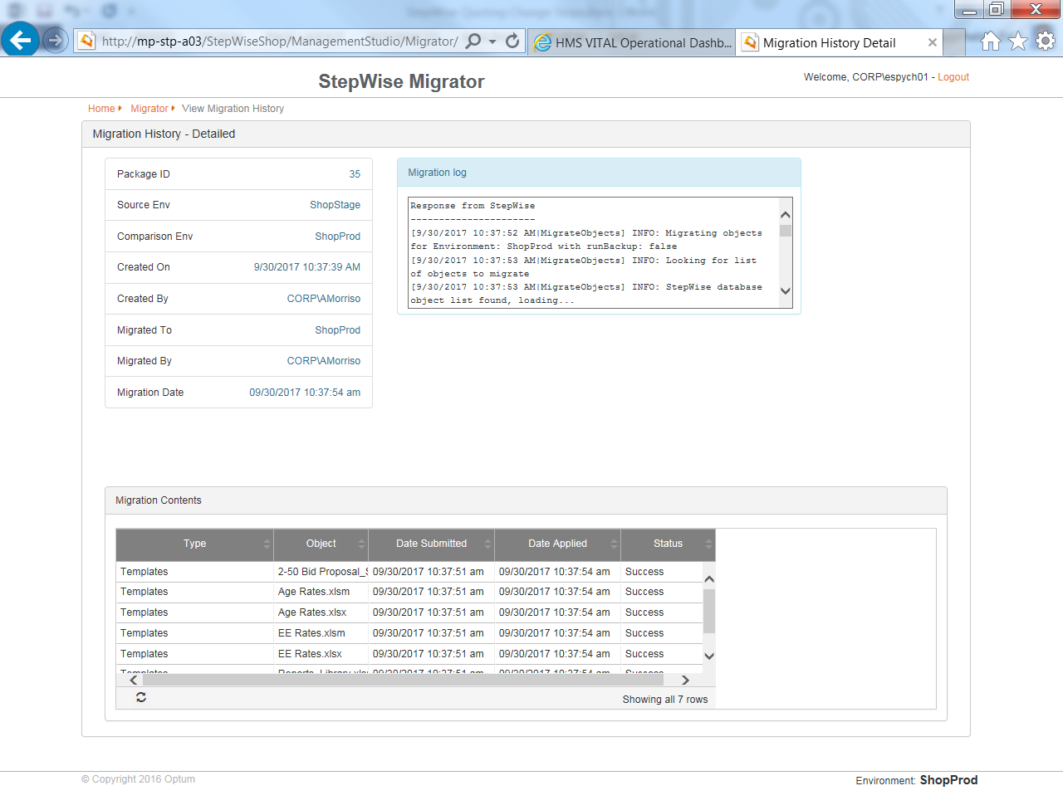

1. Restart the Services on all servers.



1. Smoke test the deployment. Verify that objects that were expected to be in the environment are there and any logic changes are present.
2. Notify the call participants that the change is complete.
3. Notify the business that the change is complete.

**Roles & Responsibilities:**

*DBA* – Backs up databases and is the only one to promote SQL scripts (if necessary) to the new environment.

*Server Services* – Can access the server and Stepwise Services that are running. During the deployment weekend, we saw an issue with the services not restarting due to the Service Account credentialing not working. Having Server Services online will allow them to help restart any services on the server that may not have started correctly.

*VAM* – Migration of the objects between the environment and basic smoke testing of change success. Also responsible for making the roll back decision if needed and any business communication.

**Appendix:**

**Killing Quotes:**

It is possible that there will be quotes in the engines when you go to shut them down. These quotes will need to be killed before continuing. This can either be due to a quote from earlier that is in a hung state or a user that may not have logged out.

1. Entering the Service Manager, you will see quote(s) in the engines. The quote(s) will be a hyperlink.

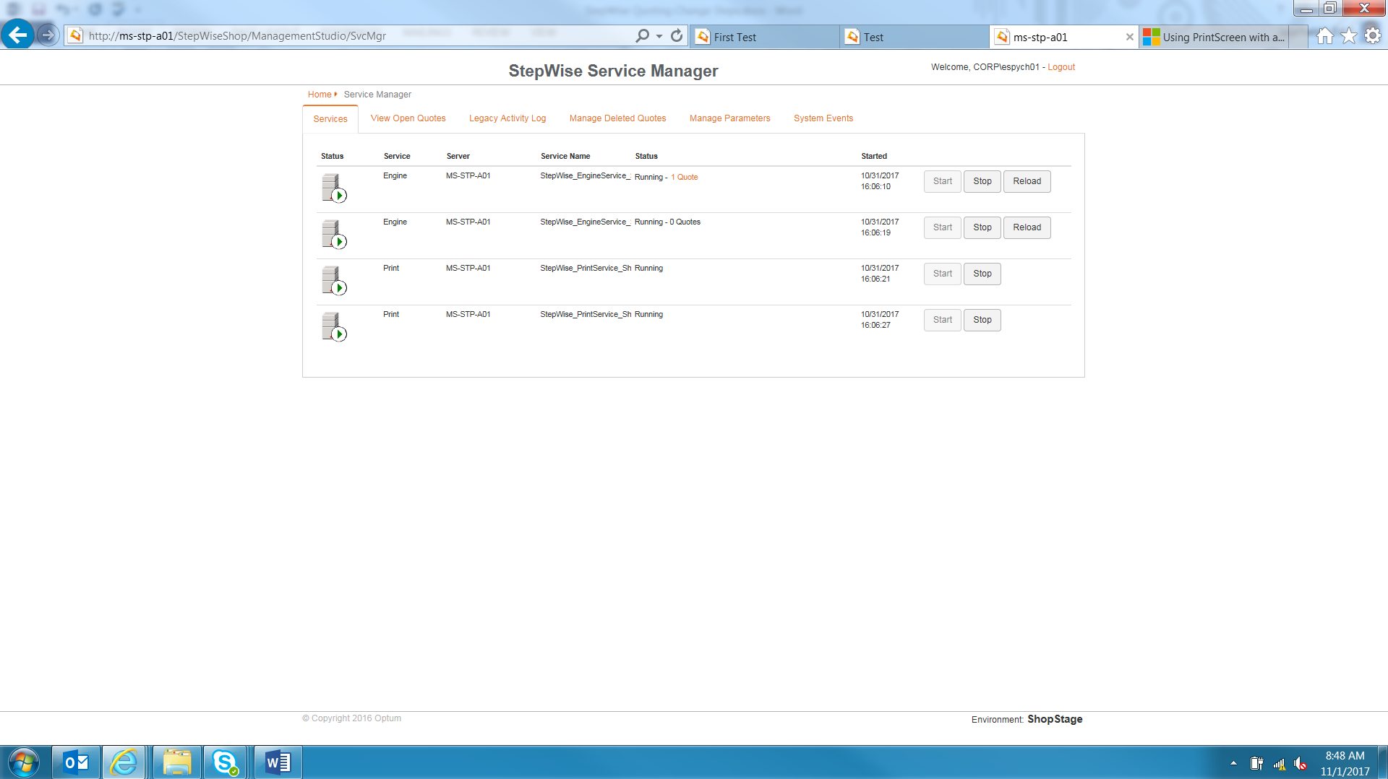

1. Click on the hyperlink. This will now display all of the information related to the quote. You can note this if you like.

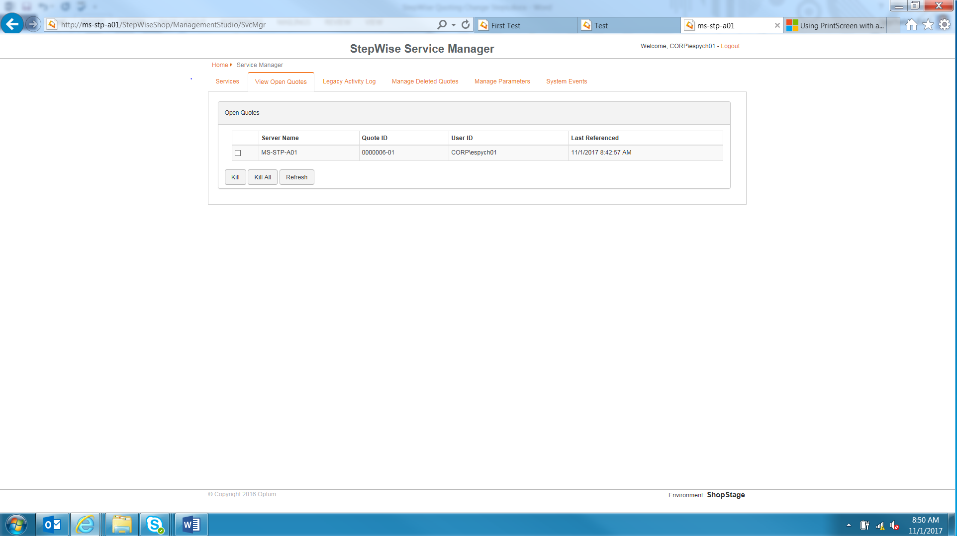

1. Select the checkboxes for all of the quotes. Click the Kill button.

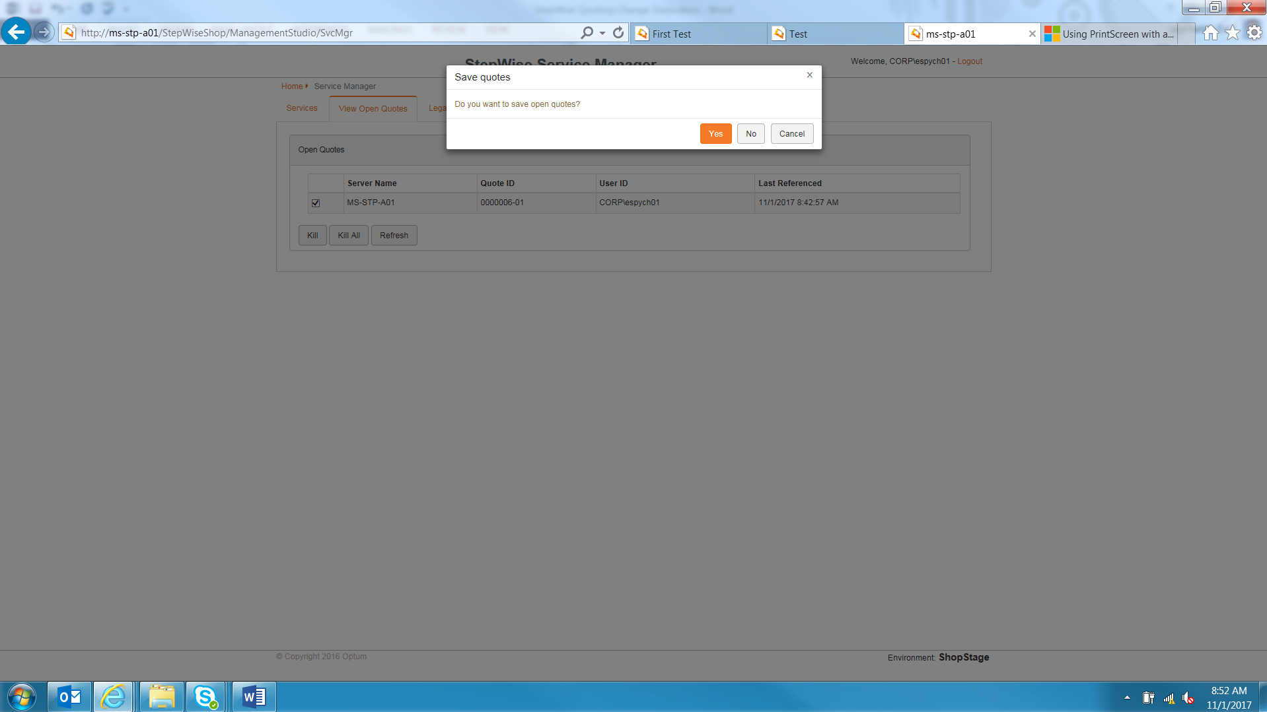

1. Click on the yes button. This will save the quote information before killing it. The screen will then go back to the open quote menu and you will no longer see quotes. Repeat for any other engines that had quotes open. When all engines are clear, resume the remainder of the change activity.

